|  |  |
| --- | --- |
|  | **Assignment 2-Machine Learning** |
|  | Professor: Dr. Yuan  Author: Kaikai Bian |

|  |
| --- |
| **[TRAINING MULTI-LAYER NEURAL NETWORKS]** |
| Predict CPU performances based on 3-layer neural network. |

**In this assignment, I used multilayer neural network to predict the relative CPU performance based on its cycle time, memory size and so on. Each data point has 7 features and 1 true output. I separated the data points into 5 folds and trained the program with the first 4 folds to obtain relative weights, and then evaluated the performance with the last fold. Through this method, I tried different thresholds to train the neural network, such as 0.1, 0.01 and 0.001, and observed a number of intriguing phenomena. The multilayer neural network is presented as follows. It has 3 layers: input layer, hidden layer, and output layer. The input layer contains 7 nodes, each representing a specific feature. The hidden layer includes 3 hidden units, and output layer has only 1 node.**

**Input layer Hidden layer Output layer**

**In the hidden layer and output layer, each unit contains a sigmoid function, g(z)=1/(1+e^(-z)). In the first layer, we feed the individual features of each data point into each node, and then in the second layer, each hidden unit will compute their weighted sum by the sigmoid function. Lastly, this result will be sent into the output unit and computed by sigmoid function. We will compare this final result with the normalized true output, obtaining the error value. Repeating this process for every data point, we will get a total error value. Our goal is to minimize this value as small as possible. In this procedure, we use some threshold to control the minimization.**

**Then we use the error values to back-propagate/adjust the weights between nodes in different layers. The program outputs the concluding result and plots chart to represent the result.**

1. **Experiment with threshold 0.1, learning rate 0.5:**

True outputs:

0: 0.13662631203770062

1: 0.01945276395282272

2: 0.02250389878858121

3: 0.04454584970970098

4: 0.021781463680551498

5: 0.022662477741453357

6: 0.04729431846916678

7: 0.02352479724694016

8: 0.02127297236775973

9: 0.025398840472375277

10: 0.03467837031390077

11: 0.03898736443420334

12: 0.01832986857389347

13: 0.019816384163121516

14: 0.026417655521321134

15: 0.03359885825191587

16: 0.03772498441677026

17: 0.07311093511407776

18: 0.04945973893039902

19: 0.057979351311830095

20: 0.10126539646652896

21: 0.13327392638286895

22: 0.22162372464718408

23: 0.3072949358961183

24: 0.04336135802633999

25: 0.13671973356584255

26: 0.18479356052680876

27: 0.25659147057674553

28: 0.30228017118856665

29: 0.4280598712041204

30: 0.4456225340467613

31: 0.022447086428511166

32: 0.02251471573240699

33: 0.02251801877789944

34: 0.02259811149003198

35: 0.031909218853160864

36: 0.03872149939706565

37: 0.033530786351742066

38: 0.03244085114339997

39: 0.01864469711959618

1. Predicted outputs:

0: 0.16234564303278823

1: 0.022087269930450636

2: 0.02358218717374349

3: 0.03933067646198036

4: 0.01891060722941621

5: 0.020186524014297613

6: 0.029666310920322646

7: 0.02647087852746494

8: 0.025408910939865904

9: 0.027826924728803347

10: 0.03360928290557056

11: 0.04058364756426368

12: 0.01831378456288683

13: 0.01891445913866375

14: 0.03744909023006027

15: 0.0430554721872489

16: 0.04577663464699074

17: 0.09206057234828785

18: 0.06864974202145964

19: 0.08089179030253793

20: 0.14473901863619076

21: 0.16678424537217193

22: 0.23810034128805393

23: 0.31681453855831526

24: 0.04712293820039068

25: 0.12368109756920194

26: 0.1701812254385226

27: 0.2475445184339292

28: 0.2761610145301684

29: 0.41653210850985334

30: 0.45405775563015693

31: 0.023727495156105425

32: 0.02418911045682533

33: 0.02384935213294908

34: 0.024334076853072817

35: 0.03536637271310129

36: 0.045982525228261566

37: 0.03818684841542592

38: 0.011841047277936735

39: 0.00930105665013697

**These two charts are the predicted outputs obtained by the program and true outputs from original data set. After comparing the two sets of outputs, we can realize that predicted outputs have been approximating to the true outputs.**

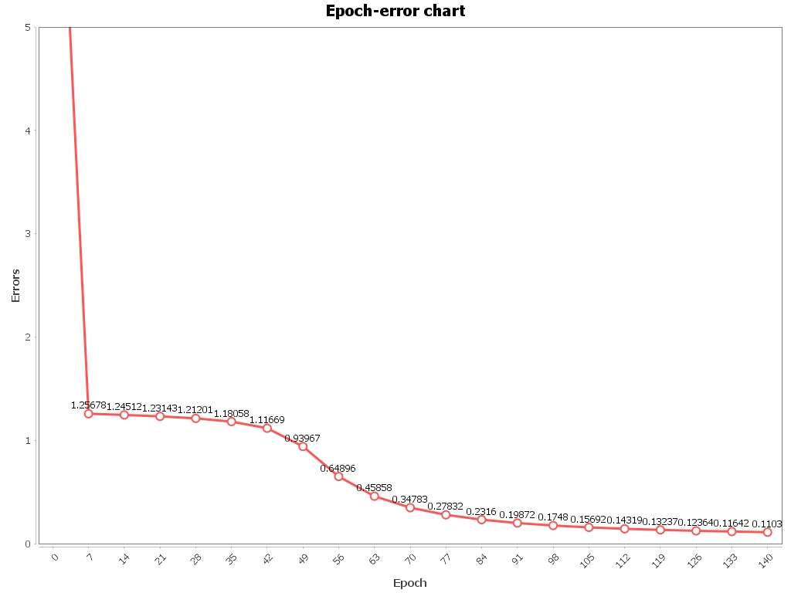

**From this chart, we observe that the total errors decrease extremely fast at the beginning, and then slow down its speed of decreasing, but during some epochs, the decreasing speeds up and then turns to be smooth. Hence, the curve presented seems to be in a sigmoid shape.**

**The weights of each edge from the input layer to the hidden layer, and then from hidden layer to the output layer are listed in the following:**

**3.068895181437563, 0.41849014363338355, 1.7457612901525108, -1.072885931992936, 1.34887688508634, 1.1545942304154517, -1.0928673614121542, 0.801740915855917, -0.45240121842682973, -0.5290747413746102, 1.0407893571603077, 1.4157968506602367, -0.3096582871373117, 1.0395087775174083, 0.13848683319738264, 0.2656114541158491, 0.394078601052223, 0.20171276779306802, -0.33297267492940114, 1.8092649076053386, 0.15717146774125512, -7.480389056034305, 0.8664460685601818, 0.1595695590521706.**

B) Predicted outputs:

0: 0.128170444469044

1: 0.025002750025844237

2: 0.02728140002221223

3: 0.04532657890897104

4: 0.022780640507001435

5: 0.023132879631694987

6: 0.04145450999107947

7: 0.029680910031756456

8: 0.026267668302573544

9: 0.030087464776955914

10: 0.038655601077157646

11: 0.04753656357308558

12: 0.020905066834287705

13: 0.02181023374114911

14: 0.035960943316589604

15: 0.03846415753451661

16: 0.045303853667868876

17: 0.09629766318105458

18: 0.06539090148741837

19: 0.07702604949984207

20: 0.12033806131553741

21: 0.1611331461233649

22: 0.23685558443364757

23: 0.2789144624030052

24: 0.043996640937949645

25: 0.14002835595653187

26: 0.12465371255121402

27: 0.09947613392371228

28: 0.12197532055781397

29: 0.45306831552369936

30: 0.5089664552746153

31: 0.027001811359842677

32: 0.02743216928488291

33: 0.027295053167212213

34: 0.027780043267545504

35: 0.039794537605506726

36: 0.04847570608731723

37: 0.04062539434818969

38: 0.019313235830591604

39: 0.01407693064996361

True outputs:

0: 0.13662631203770062

1: 0.01945276395282272

2: 0.02250389878858121

3: 0.04454584970970098

4: 0.021781463680551498

5: 0.022662477741453357

6: 0.04729431846916678

7: 0.02352479724694016

8: 0.02127297236775973

9: 0.025398840472375277

10: 0.03467837031390077

11: 0.03898736443420334

12: 0.01832986857389347

13: 0.019816384163121516

14: 0.026417655521321134

15: 0.03359885825191587

16: 0.03772498441677026

17: 0.07311093511407776

18: 0.04945973893039902

19: 0.057979351311830095

20: 0.10126539646652896

21: 0.13327392638286895

22: 0.22162372464718408

23: 0.3072949358961183

24: 0.04336135802633999

25: 0.13671973356584255

26: 0.18479356052680876

27: 0.25659147057674553

28: 0.30228017118856665

29: 0.4280598712041204

30: 0.4456225340467613

31: 0.022447086428511166

32: 0.02251471573240699

33: 0.02251801877789944

34: 0.02259811149003198

35: 0.031909218853160864

36: 0.03872149939706565

37: 0.033530786351742066

38: 0.03244085114339997

39: 0.01864469711959618

1. **Experiment with threshold 0.1, learning rate 0.5:**

**The predicted outputs approximate to the true outputs.**

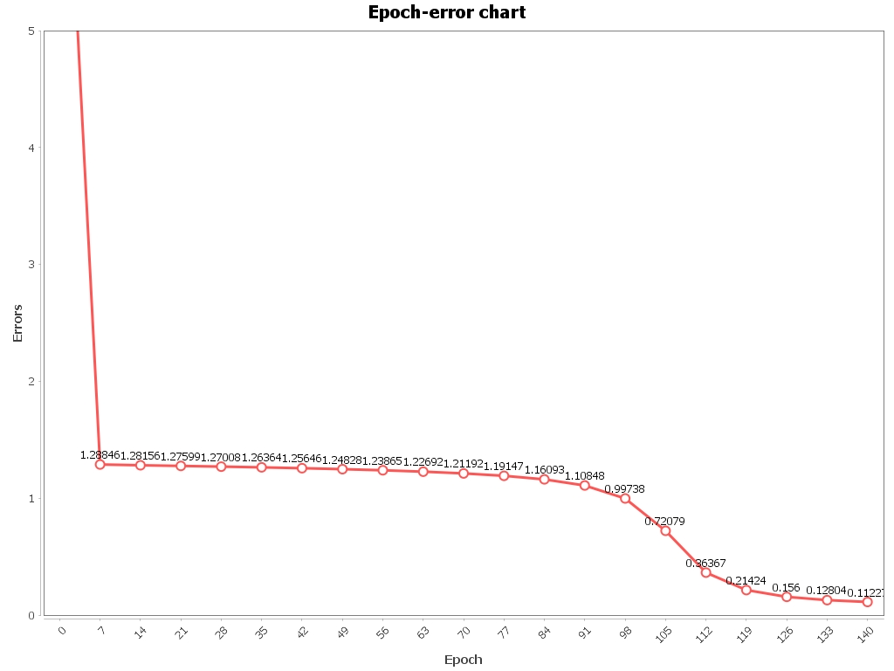

**In this chart, we find that the turnaround appears later than the first experiment.**

**The weights of edges are listed as follows:**

**2.018319404590006, 0.5285060509673671, 2.4429370174031297, 0.01575942410892352, 0.08716352836794658, -1.5998170002863852, -1.657367330213325, 1.5177646198131947, -1.1673063142855102, -0.4102739936505453, 0.30106480126776175, -0.6803318962773288, -0.07389039895083285, 0.9697464834795433, 0.8153226379793883, 0.9713073617633685, 0.9489746144386406, 0.3816388957190291, -1.250662341191915, 1.764016187050276, -0.6501337314940963, -3.453059579607419, 0.9257277536388722, -4.048235846779631.**

**This set of weights differs from the first set of weights; hence there does not exist a “standard” weight the network approaches to.**

**In the following, I plot all the weights of both the first and second experiment.**

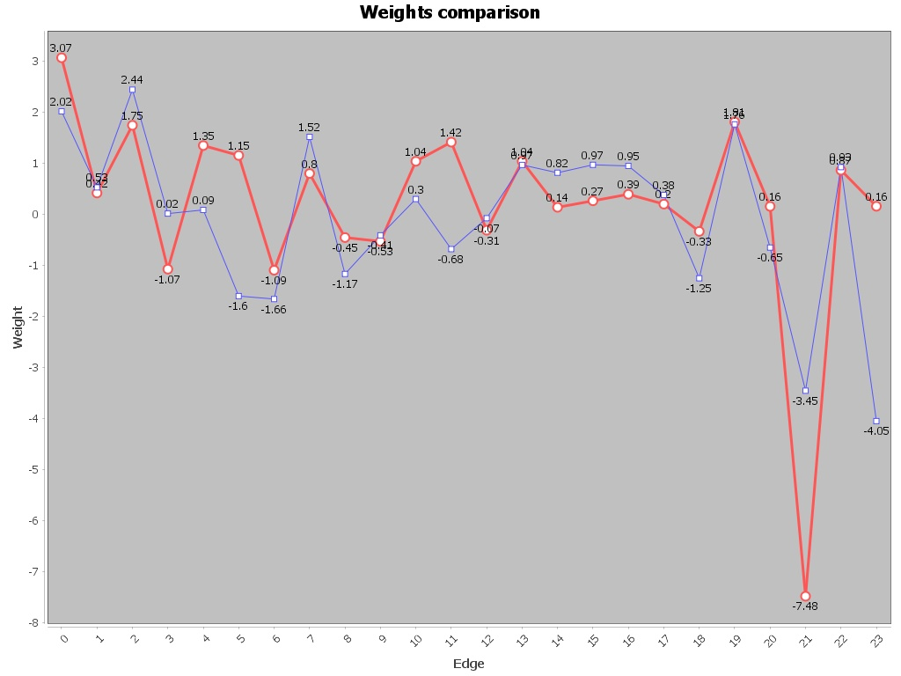

**We can observe that the weights of edges with threshold of 0.1 are approximate and show similar behaviors in different edges.**

1. **Experiment with threshold 0.01, learning rate 0.5:**

**The predicted outputs approximate to the true outputs.**

Predicted outputs:

0: 0.14353130878431275

1: 0.021523093045630992

2: 0.02438180862352515

3: 0.04642538649130571

4: 0.023575889531713017

5: 0.024738491644665284

6: 0.04846356568606686

7: 0.024865032959642284

8: 0.022772351994301207

9: 0.02663933057496433

10: 0.03550475312911368

11: 0.04073706577386507

12: 0.020304228760979905

13: 0.02169576556512996

14: 0.028014819316731082

15: 0.03472714232810496

16: 0.03857314378838864

17: 0.07224099930001567

18: 0.05061057414283853

19: 0.059052412776346465

20: 0.10649926204401547

21: 0.1287123364794501

22: 0.21271941148951617

23: 0.32009179433908563

24: 0.043760306702655516

25: 0.14574842391833231

26: 0.22258747672731327

27: 0.36592897608538966

28: 0.3932997582786706

29: 0.8091616046150388

30: 0.8505117397924159

31: 0.023817554597919097

32: 0.024002874494572533

33: 0.0239133463299115

34: 0.024115509480021786

35: 0.03242322163237453

36: 0.039394781746132077

37: 0.03426881115624963

38: 0.031964467286332676

39: 0.021074672216177728

True outputs:

0: 0.13662631203770062

1: 0.01945276395282272

2: 0.02250389878858121

3: 0.04454584970970098

4: 0.021781463680551498

5: 0.022662477741453357

6: 0.04729431846916678

7: 0.02352479724694016

8: 0.02127297236775973

9: 0.025398840472375277

10: 0.03467837031390077

11: 0.03898736443420334

12: 0.01832986857389347

13: 0.019816384163121516

14: 0.026417655521321134

15: 0.03359885825191587

16: 0.03772498441677026

17: 0.07311093511407776

18: 0.04945973893039902

19: 0.057979351311830095

20: 0.10126539646652896

21: 0.13327392638286895

22: 0.22162372464718408

23: 0.3072949358961183

24: 0.04336135802633999

25: 0.13671973356584255

26: 0.18479356052680876

27: 0.25659147057674553

28: 0.30228017118856665

29: 0.4280598712041204

30: 0.4456225340467613

31: 0.022447086428511166

32: 0.02251471573240699

33: 0.02251801877789944

34: 0.02259811149003198

35: 0.031909218853160864

36: 0.03872149939706565

37: 0.033530786351742066

38: 0.03244085114339997

39: 0.01864469711959618

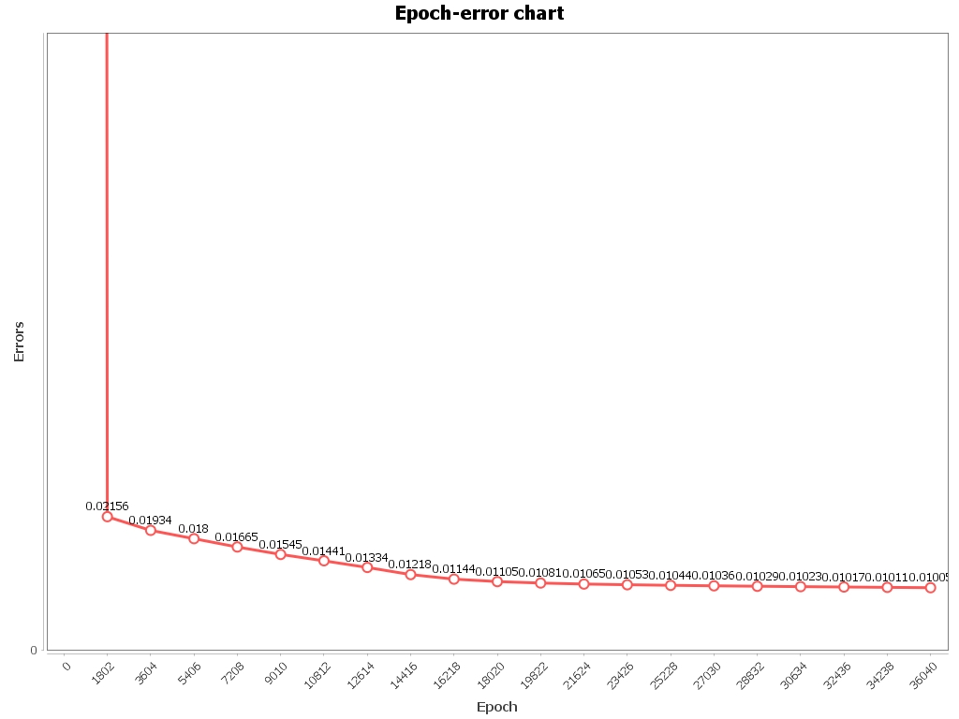

**In this chart, I minimize the range of the y-axis to 0-0.1. We can observe that the errors diminish tremendously fast at the beginning epochs and then the curve turns to be comparatively smooth. It does not show any sigmoid shape in this chart.**

**The following are the weights of individual edges:**

**0.9677050696130661, 0.34790988909321685, 0.46857161549405485, -0.06608713501686682, 1.6478435166989351, 0.4490712319405222, -1.0019606073023417, -2.469915093528045, -1.9972627899498956, -0.25800363430126455, -3.5988521136534346, -1.7705595514858359, 1.8111099698058224, 0.6056643182130607, 0.41968147428302033, 0.0026008244148482264, 2.5681691036445256, 0.9234045447394361, 0.9201591509449241, 2.029920094124157, 0.7806903782624406, 3.0916246231657736, 7.052500279518403, -17.937293724639815.**

1. **Experiment with threshold 0.01, learning rate 0.5:**

**The predicted outputs approximate to the true outputs.**

Predicted outputs:

0: 0.14328500702185534

1: 0.02159878164365376

2: 0.024422403063100274

3: 0.04583846907198754

4: 0.023580602522410135

5: 0.024785944709536104

6: 0.04796945235426951

7: 0.02489189593310087

8: 0.02287396943753777

9: 0.026691791897841606

10: 0.03541679229161842

11: 0.04064047867851734

12: 0.020349513629587316

13: 0.021724870704166354

14: 0.028174469460148968

15: 0.034908049310852625

16: 0.038654942042921074

17: 0.07209310910775552

18: 0.050795510887247035

19: 0.059194983513276615

20: 0.10721926921829575

21: 0.12816656300088436

22: 0.21254164923320903

23: 0.3243113257374739

24: 0.04383526495631184

25: 0.14554673657783823

26: 0.22414155423927123

27: 0.33129114571823337

28: 0.35195454533996595

29: 0.8048410326547644

30: 0.8407174407942802

31: 0.023826465505207853

32: 0.02402380174422875

33: 0.023922736114794334

34: 0.02413695609054437

35: 0.03239378262368602

36: 0.03923206137589717

37: 0.03434758735833371

38: 0.031365061427975634

39: 0.021020230081033108

True outputs:

0: 0.13662631203770062

1: 0.01945276395282272

2: 0.02250389878858121

3: 0.04454584970970098

4: 0.021781463680551498

5: 0.022662477741453357

6: 0.04729431846916678

7: 0.02352479724694016

8: 0.02127297236775973

9: 0.025398840472375277

10: 0.03467837031390077

11: 0.03898736443420334

12: 0.01832986857389347

13: 0.019816384163121516

14: 0.026417655521321134

15: 0.03359885825191587

16: 0.03772498441677026

17: 0.07311093511407776

18: 0.04945973893039902

19: 0.057979351311830095

20: 0.10126539646652896

21: 0.13327392638286895

22: 0.22162372464718408

23: 0.3072949358961183

24: 0.04336135802633999

25: 0.13671973356584255

26: 0.18479356052680876

27: 0.25659147057674553

28: 0.30228017118856665

29: 0.4280598712041204

30: 0.4456225340467613

31: 0.022447086428511166

32: 0.02251471573240699

33: 0.02251801877789944

34: 0.02259811149003198

35: 0.031909218853160864

36: 0.03872149939706565

37: 0.033530786351742066

38: 0.03244085114339997

39: 0.01864469711959618

**Since the threshold has been limited to 0.01, the predicted outputs approximate the true outputs much better than the experiments with threshold of 0.1.**

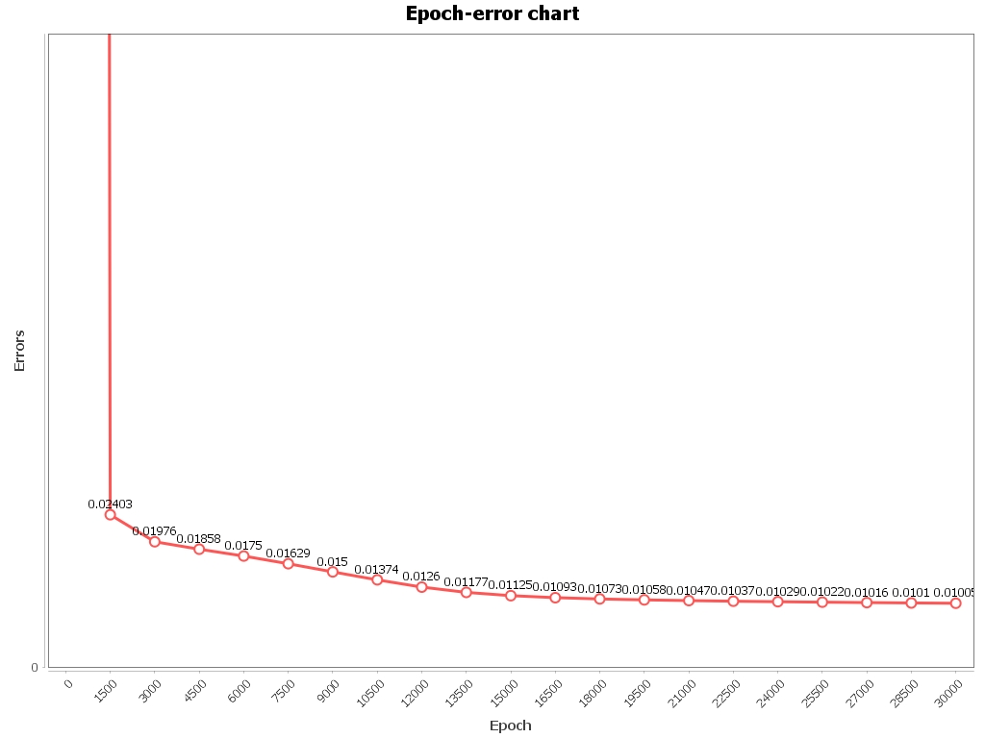

**This chart shows us a similar curve with the last experiment. Decrease excessively fast at the beginning and then suddenly turn to be flat. This is because the more epochs the program run, the smaller error values it can deduct.**

**The weights of edges are as follows:**

**0.678690983373701, 0.6068863039134603, 0.524646535931502, -0.17063370526707775, 0.8628670472529243, 0.0759031696323422, -1.040609826070455, -2.5474263826866292, -1.9865953556753397, -0.3240081004553215, -3.5830423534353257, -1.6806000864403148, 1.806765987961375, 0.7876696424628783, 0.4899835643204287, 1.0098485289171895, 2.4174115922643193, 0.9828101024967129, 0.7431927715844727, 2.8409254065287715, 0.9983520891489454, 3.3501928486074566, 6.400930375056133, -17.533588571777887.**

**Comparing the two weights, observe that the last 3 weights, which represent the edges between the hidden layer and output layer, are approximate.**

**I also made a chart to present the weights to observe whether I can find some differences. With threshold of 0.01, the two sets of weights are so matching.**

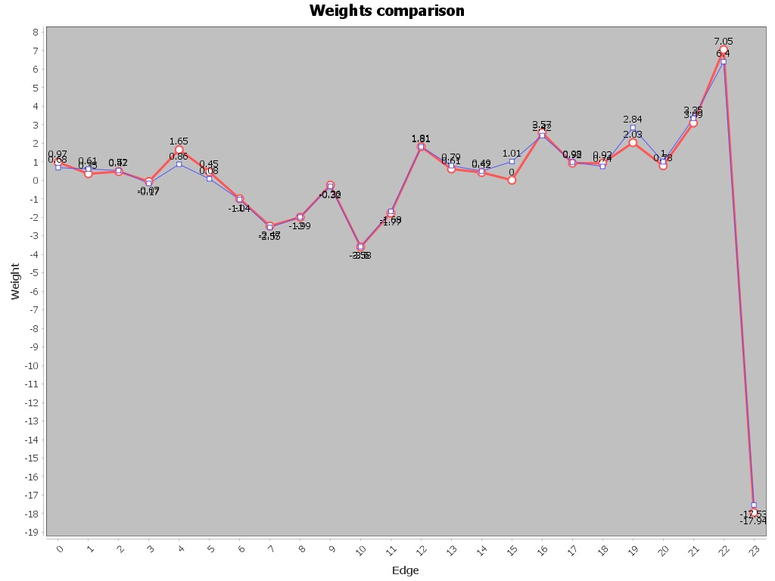

1. **Experiment with threshold 0.001, learning rate 0.5:**

**This set of predicted outputs approximate the true outputs much better than the previous ones.**

Predicted outputs:

0: 0.15395832155958536

1: 0.019907276478122814

2: 0.022438362541108776

3: 0.05033698973477141

4: 0.021151608566556894

5: 0.022340702937165263

6: 0.045299991751305356

7: 0.023037500700144133

8: 0.021275444624160245

9: 0.02453501395624639

10: 0.032794023779363655

11: 0.03833823090128563

12: 0.019010946258596725

13: 0.020159236637897027

14: 0.028084348760532847

15: 0.03585226914705448

16: 0.037991561213797174

17: 0.07253123533465182

18: 0.052862546351832795

19: 0.06061703023682995

20: 0.11117821666039664

21: 0.13511917421048128

22: 0.201552745606094

23: 0.2977114518283195

24: 0.04296664967348548

25: 0.15083016404147942

26: 0.2156450379716417

27: 0.33050782559310177

28: 0.34410280696204487

29: 0.2500059880769084

30: 0.037521400681617835

31: 0.02218334934334096

32: 0.022420271163714214

33: 0.022141216140547912

34: 0.02236847908120996

35: 0.030250652712183225

36: 0.03944648596839876

37: 0.03226384832493776

38: 0.029350323805796878

39: 0.01782590125208908

True outputs:

0: 0.13662631203770062

1: 0.01945276395282272

2: 0.02250389878858121

3: 0.04454584970970098

4: 0.021781463680551498

5: 0.022662477741453357

6: 0.04729431846916678

7: 0.02352479724694016

8: 0.02127297236775973

9: 0.025398840472375277

10: 0.03467837031390077

11: 0.03898736443420334

12: 0.01832986857389347

13: 0.019816384163121516

14: 0.026417655521321134

15: 0.03359885825191587

16: 0.03772498441677026

17: 0.07311093511407776

18: 0.04945973893039902

19: 0.057979351311830095

20: 0.10126539646652896

21: 0.13327392638286895

22: 0.22162372464718408

23: 0.3072949358961183

24: 0.04336135802633999

25: 0.13671973356584255

26: 0.18479356052680876

27: 0.25659147057674553

28: 0.30228017118856665

29: 0.4280598712041204

30: 0.4456225340467613

31: 0.022447086428511166

32: 0.02251471573240699

33: 0.02251801877789944

34: 0.02259811149003198

35: 0.031909218853160864

36: 0.03872149939706565

37: 0.033530786351742066

38: 0.03244085114339997

39: 0.01864469711959618

**The program ended while it had not reached the threshold but reached the minimum error values. Becauase the weights were initialized randomly, it can lead to half-way ending like this. Nevertheless, observe that the predicted values still approximate the true much better than the previous ones.**

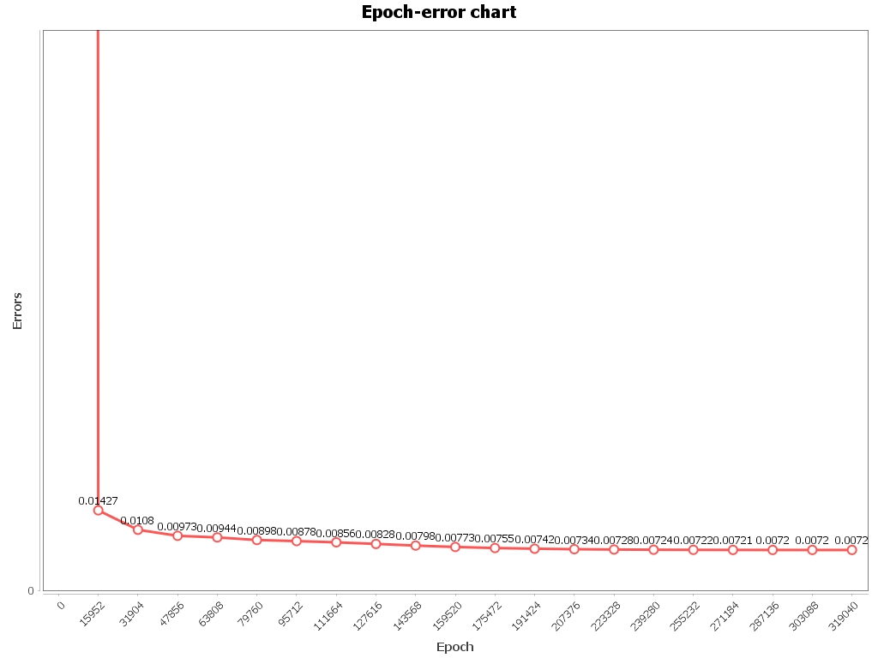

**The chart of threshold of 0.001 just resembles the counterpart of threshold of 0.01 with slight difference. It turns to be smoother and there seems to be no deduction in the end.**

**The weights of edges are listed in the following:**

**-2.303588050168534, -1.071318092847127, -1.6415469951438375, -3.5606258113467306, -1.6078861146336052, -0.4329588215459802, -3.45837174868928, -2.407584457364578, -1.699773589498611, -1.2001421049479393, -1.9917597691144382, -4.0500739008088456, -2.0873464162398805, -1.3360145383117643, -1.3880415715060503, -0.5455611948926716, 0.7390912328431472, 3.026047231181294, 9.532180610998084, 4.648891693869785, 4.358121493013824, 8.050091877820153, -22.78140558046731, 6.929937367880352.**

1. **Experiment with threshold 0.001, learning rate 0.5:**

**This set of predicted outputs approximate the true outputs much better than the previous ones, even though it stopped at the 596754 epochs since it reached the minimum value of total errors.**

True outputs:

0: 0.13662631203770062

1: 0.01945276395282272

2: 0.02250389878858121

3: 0.04454584970970098

4: 0.021781463680551498

5: 0.022662477741453357

6: 0.04729431846916678

7: 0.02352479724694016

8: 0.02127297236775973

9: 0.025398840472375277

10: 0.03467837031390077

11: 0.03898736443420334

12: 0.01832986857389347

13: 0.019816384163121516

14: 0.026417655521321134

15: 0.03359885825191587

16: 0.03772498441677026

17: 0.07311093511407776

18: 0.04945973893039902

19: 0.057979351311830095

20: 0.10126539646652896

21: 0.13327392638286895

22: 0.22162372464718408

23: 0.3072949358961183

24: 0.04336135802633999

25: 0.13671973356584255

26: 0.18479356052680876

27: 0.25659147057674553

28: 0.30228017118856665

29: 0.4280598712041204

30: 0.4456225340467613

31: 0.022447086428511166

32: 0.02251471573240699

33: 0.02251801877789944

34: 0.02259811149003198

35: 0.031909218853160864

36: 0.03872149939706565

37: 0.033530786351742066

38: 0.03244085114339997

39: 0.01864469711959618

Predicted outputs:

0: 0.18398331713591112

1: 0.020492677187749064

2: 0.023059338592774023

3: 0.05238540126251654

4: 0.02191568158787993

5: 0.022677564672001563

6: 0.04517199974629256

7: 0.02334337451561981

8: 0.021360635271119824

9: 0.02529751131800165

10: 0.033578994297624835

11: 0.03940284756586978

12: 0.019727424730594207

13: 0.020919190681247885

14: 0.02811111880031169

15: 0.03498109905562144

16: 0.03797324187854435

17: 0.0731335408173717

18: 0.050728326222084515

19: 0.060477346370635725

20: 0.11239708543345224

21: 0.12854770104064112

22: 0.21159097256048837

23: 0.34825876497976493

24: 0.04336811002184157

25: 0.14283470790646297

26: 0.1767762271376241

27: 0.2532312209240168

28: 0.2600245264828188

29: 0.9234776332593072

30: 0.962066796744213

31: 0.02249974421191948

32: 0.02278380201051014

33: 0.02246514417084856

34: 0.0227467151890991

35: 0.03041828473841803

36: 0.040022129661610464

37: 0.03271587638676319

38: 0.03564317409050222

39: 0.0196536451577331

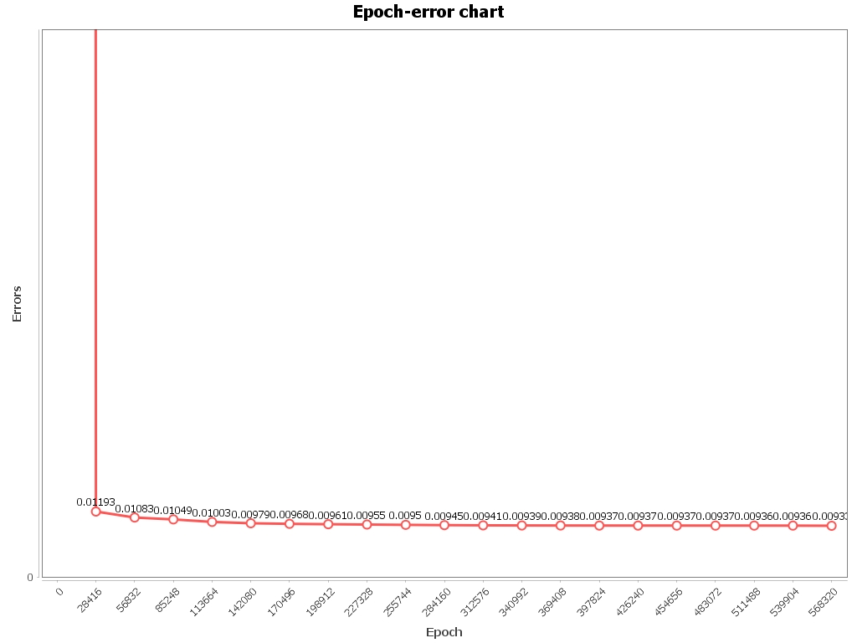

**The chart of threshold of 0.001 just resembles the counterpart of threshold of 0.01 with slight difference. It turns to be smoother and there seems to be no deduction in the end.**

**The weights of edges are shown here:**

**0.8782608557089355, -1.743380771995503, -0.680876621048059, 7.69725590114782, 2.985210976970883, 1.8877990193962224, 3.072688792182264, -2.2497246050484336, -1.6812939656435737, 4.206084210803893, -3.74262647427343, -2.0186935124067555, 0.7154381142372433, -2.279765485828273, -1.2827617249981593, -7.348833171263777, 3.853123086128208, 1.3911331502343023, -8.75192315911962, 1.7963697672327623, 0.2637185657998494, 1.7376931053168096, 10.96651069192475, -20.572450299699547.**

**Observe that the weights are still random and does not resemble its counterpart of another trial with same threshold.**

**In a nutshell, we could find that when the threshold approaches to being smaller, the curve tends to be smoother and the significant deduction only occurs in the beginning epochs. Although it takes enormous amount of time to compute for the threshold of 0.001 or it ends when approximating the minimum error, it still provides much accurate results when compared with larger thresholds such as 0.1 and 0.01.**

**For this pair of experiments, the charts do not show any matching between the two weights, but we still can find they share the same tendency in the chart when the input values go into higher layer of the neural networks.**

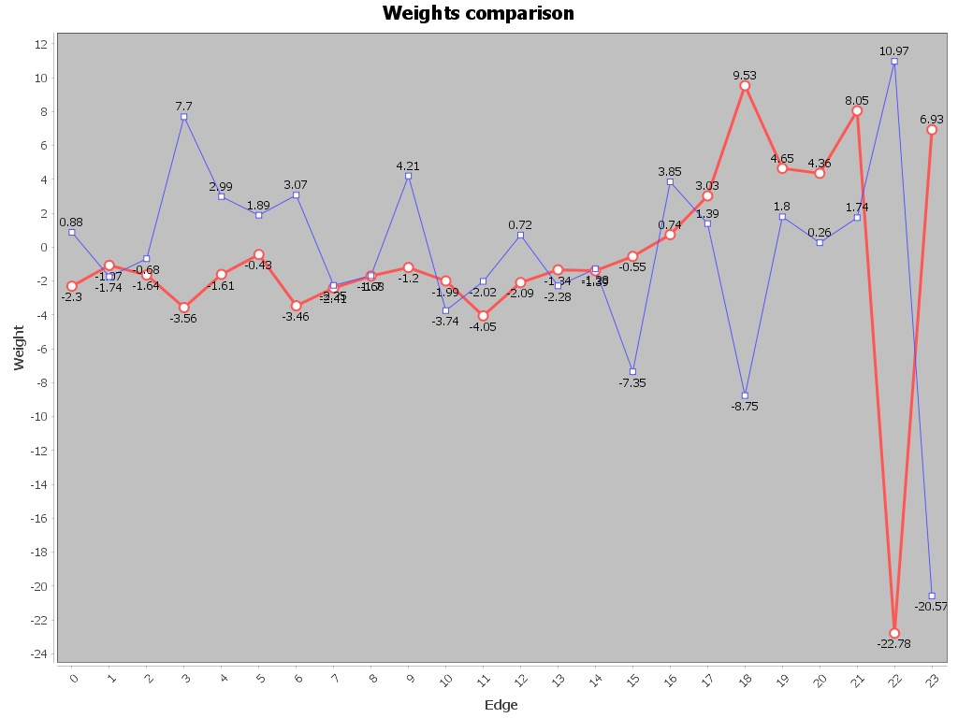

**Lastly, I gather all the weights of experiments with different thresholds and plot them into one chart. As what we observe, the edges between the input layer and hidden layer have similar weights but the edges between hidden layer and output layer can vary significantly.**

